# Sketch and Evidence Mapping

Table

Seat

Seat



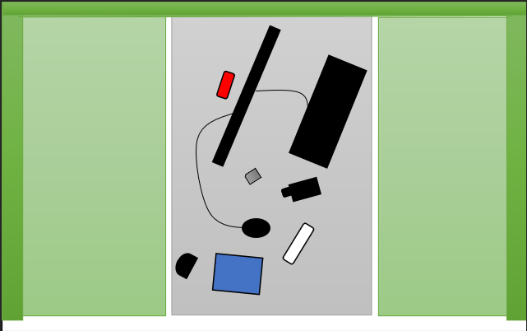

8

9

7

6

5

4

3

2

1

|  |  |
| --- | --- |
| Evidence Number | Item Name |
| 1 | ‘Jet Lis Fearless’ DVD – With the note ‘Lamborghini@’ inside |
| 2 | IDECT cordless phone |
| 3 | O2 dongle – Includes an EE sim card |
| 4 | HP Desktop Mouse |
| 5 | Ericsson Phone |
| 6 | PNY SD card adapter |
| 7 | HP Desktop Keyboard |
| 8 | HP Desktop Monitor |
| 9 | SanDisk Cruiser Blade USB stick (16gb) |

# Audit

This Audit shows a professional understanding of how a first responder would conduct an investigation. These audits and methods to conduct this investigation prove the ACPO and Enisa first responders principles are upheld.

Auditor: Abdur-rahman Patel

Date: 14/02/2022

Time: 1:05

On Scene Personnel: Mahmood, Abdur-rahman, Officer Taggart

[1:05]: Investigation Commences

[1:05]: Talked to investigation leader, Police Officer James Taggart on investigation briefing. He also provides proof of warrant.

[1:07]: Took a sketch of the Layout of the crime scene including evidence locations

[1:08]: Prepped and wore PPE before entering the crime scene with adherence to personal and environmental safety.

[1:09]: Took photos of the outer crime scene

[1:09]: Identified and labelled each piece of evidence

[1:10]: Took photos of each piece of evidence

[1:12]: Opened up and took photos inside devices

[1:14]: Identified Serial/ IEMI numbers of devices and took photos of them

[1:15]: Pieces of evidence if moved have been correctly put back to its original state.

[1:15] Investigation Ends